UCTP Benchmarking Framework:
Breakdown and Prospective Actions

Author: Miles Puchner
Revised: 19 August 2025

Overview
The framework can be broken down into two main pipelines, dataset generation and evaluation. Dataset generation concerns all necessary algorithms needed to generate the user-specified dataset to be passed to the UCTP. Put succinctly, the workflow for this section includes the dataset criteria GUI, pulling data from the UDL, refining the data into windows of fitspan size, simulating or downsampling the real data to obtain a more accurate representation of the desired criteria, ensuring the dataset matches the input type for the UCTP (observations, TLEs, etc.), and decorrelating the dataset such that it can be given to the UCTP. This decorrelated data is then passed to the UCTP which marks the end of the dataset generation pipeline.

Evaluation concerns all necessary algorithms needed to evaluate the UCTP’s results and create the benchmarking report. This includes orbit association in which candidate and reference orbits are compared (re-correlated), various metrics and submetrics that comprehensively quantify the validity of the UCTP output, and the benchmarking report generation.

At the current timestamp of this report, a minimum-viable product (MVP) exists that incorporates most of the above. The extent of what is integrated is better outlined in Benchmarking Documentation, however a basic summary of this and what should be added in the future will be summarized here. It should be heavily emphasized that there is always room for improvement; algorithms that have already been incorporated should still be evaluated for efficiency and compatibility.

Dataset Generation Pipeline
Dataset GUI
An extremely basic GUI exists that incorporates currently supported criteria, with the exception of events which must be integrated once event labelling (via the Labelling Team) is complete. Assuming other dataset criteria become supported in the future, the GUI must be expanded to include them. A more refined, professional-looking GUI should also be worked on. This GUI would ideally contain sliders, check boxes, and in-depth descriptions that allow for optimal UI/UX. In other words, there should be no ambiguity in what each option represents and no confusion on how to use the GUI.

Dataset Criteria and Codes
This section marks the bulk of the needed work within the dataset generation pipeline. This is due to additional criteria requiring their own specific algorithms and scripts in order to get them integrated.
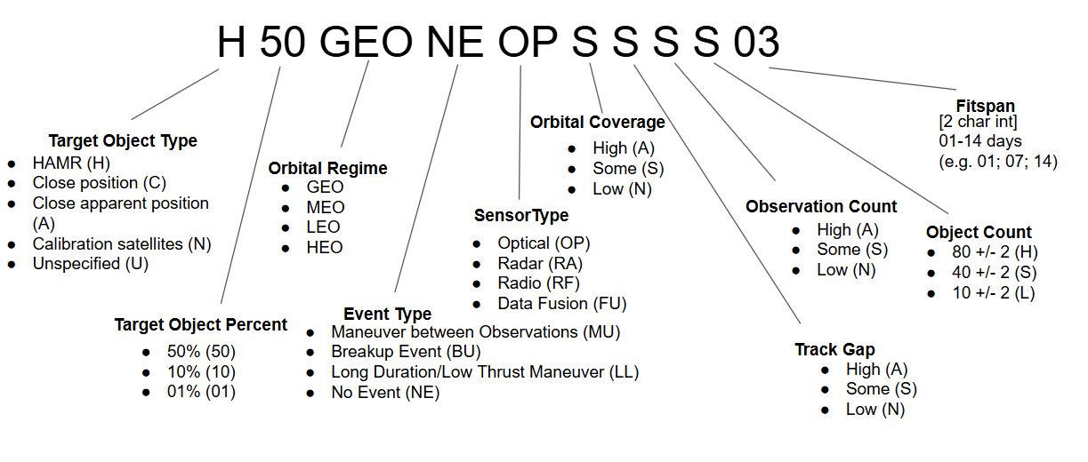
For example, Close Position and Close Apparent Position target objects have not yet been integrated. Therefore logic must be written to distinguish these objects from the raw UDL data. As stated earlier, event types must also be integrated, however this must wait until the labelling team’s work is complete. Finally, only optical data (sensor type) is currently supported by the framework due to data access constraints. Incorporating more types of data will be the most difficult addition to the framework as it fundamentally changes most scripts and algorithms that follow. For instance, how track gap is computed will vary depending on if the data is in the form of raw observations or radar. Similarly, the metrics within the Evaluation pipeline will need to be altered such that the computation supports the datatype in question. With that said, the general framework and flow remains the same, only the computation of certain metrics must be altered. The last thing to add would be a date marker for when each dataset is generated. This would allow the user to create newer or older data at their discretion.

Dataset Database
When the naming schema for the datasets was derived, the ability to pull from existing datasets was envisioned. This was planned to be done through a database of datasets in which created datasets are stored and accessed via the unique dataset code identifier. This would allow for ease of recycling datasets as well as culling datasets that are physically impossible to create. In the case of dataset recycling, one would be able to pull a previously created dataset if its dataset code matches closely with the currently desired dataset criteria. For example, a dataset code marked “A10 MEO NE OR AAAS 02” can be recycled from “A20 MEO NE OR AAAS 02” via downsampling from 20% to 10% of the target object. Logic describing all possible scenarios for when a dataset can be recycled must be engineered. Work on this was started, however due to time constraints and being lower priority, no significant logic has been derived. Note that most criteria are not mutually exclusive, therefore altering one via downsampling will likely affect others; this must be carefully considered when this logic is written.

Window Selection and Scoring
The window selection algorithm on its own can be considered complete with the exception of optimization. However, the scoring function needs refinement. A recent flaw in the logic between Tier 1 and Tier 2 scoring was found that must be resolved. Currently, the window selection algorithm will discard bisected batches of data if they do not meet the desired data tier specified by the user. However, bisecting a batch of data (making it smaller) can have the same effect as downsampling, therefore a batch of data marked T2 (in need of downsampling) may become T1 after it is bisected. However, if the user wants T1 data only, then that T2 batch of data will be discarded before bisection takes place, meaning that the T1 data contained will be lost. As a quick fix, T1 and T2 data tiers have been combined into a single tier so as to consider them equal. Ideally a fix that can keep these tiers separate while still resolving this issue should be derived. Additionally, the scoring function will need to be amended every time a new dataset criteria is added. For example, once events are added, scoring will need to consider the quality of the data relative to the event. Finally, the scoring function should be tested for robustness and optimized if needed.

Simulation
This is another area of the framework that will require significant work every time a new datatype is added. Currently, only observation data can be simulated with Gaussian noise as the primary ‘blur.’ This must be expanded during data fusion such that data from other sensor types can be simulated. Research into quantification of the error that stellar aberration and atmospheric refraction introduce to optical observations was conducted (found here), however due to time constraints it was never implemented. Therefore, modeling physically accurate noise on simulated optical data is a necessary addition, and should replace the currently implemented basic Gaussian blur. Similarly, once research on error quantification is done for other sensor types, this will also need to be added.

Downsampling
Similar to simulation, downsampling will need to be reworked every time a new sensor type is added. The general logic and flow can likely stay the same, however careful consideration to which data points are removed must be considered so as to not mess with other dataset criteria. For example, if observations need to be removed to meet the observation number requirement, they cannot be removed at random, otherwise criteria such as track gap or coverage will likely be affected.

Input Datatype Matching
Currently, the only two input types seen in UCTPs are raw observations and TLEs. Therefore, the only input conversion integrated so far is from observations to TLEs. This is done through a modified Gauss IOD that has proven unreliable. Consider replacing the Gauss IOD with a more modern and robust IOD algorithm. This should be easy to do as the framework is there, one must simply call the new IOD rather than the current Gauss implementation. Should one come across other UCTP input types, then other conversions to these input types must be added. In essence, every conversion combination of sensor type data (optical, radar, rf, etc) to UCTP input data types (observations, TLEs, etc) must be developed; currently only optical to observations and optical to TLEs is supported.

Decorrelation
This will only need to be edited once more sensor types are integrated. Again, the framework is there, however due to differing structures between data types, the algorithm outlining how data is decorrelated may need to be changed. This should not be challenging.

Evaluation Pipeline
Orbit Association
This will only need to be edited once more sensor types are integrated. Again, the framework is there, however due to differing structures between data types, the algorithm outlining how data is recorrelated may need to be changed. This should not be challenging.

State Metrics
Like all other metrics, a version of this metric may need to be created if new sensor types or UCTP input datatypes are added. Further stochastic measures may need to be implemented into this metric on a case by case basis as some metrics are exclusive to specific datatypes.

Residual Metrics
Like all other metrics, a version of this metric may need to be created if new sensor types or UCTP input datatypes are added. Further stochastic measures may need to be implemented into this metric on a case by case basis as some metrics are exclusive to specific datatypes.

Binary Metrics
Like all other metrics, a version of this metric may need to be created if new sensor types or UCTP input datatypes are added. Further stochastic measures may need to be implemented into this metric on a case by case basis as some metrics are exclusive to specific datatypes.

Evaluation Report
The report needs to be expanded depending on the implementation and integration of aspects above. For instance, should more metrics be added, or different stochastic sub-metrics be used, the report should reflect this. A UI/UX overhaul, may also be necessary for ease of reading. Logic to condense all of the metrics into one quality score ‘Q-score’ should be looked into. A single value score will allow for easier comparison between UCTPs, motivating possible algorithm feedback and advancement via OpenEvolve.

General Additions
Cloud Hosting
The framework in its entirety, including all dependencies and libraries, must be containerized (docker) so that it can be cloud hosted. This should help with runtime as the current bottlenecks will see significant improvement with the increased compute available via cloud hosting.

Optimization
Again, it cannot be over stated that there is always room for improvement. Current, new, and planned algorithms should always be scanned for the purpose of optimization. This includes, but is not limited to, multi-core processing integration, script restructuring, and algorithm replanning.

Testing
The framework still lacks validation as getting access to UCTPs was not possible in the allotted 10 weeks. Inquire with UCTP providers; send them input datasets for them to run through their algorithms and ask for the output data to be returned so that both pipelines can be stress tested.

OpenEvolve
See about integrating OpenEvolve logic using the already engineered metrics as a point of comparison. In other words, use the metrics from the Evaluation pipeline to inform possible enhancements to the providers’ algorithms via OpenEvolve. This would be a nice addition to the scope of the framework but is not necessary should time not permit; do this last. See the OpenEvolve Proposal for more details.

Summary
The following flow chart summarizes the framework breakdown and outlines areas of future work. Subsections are color coded to indicate connections between them; i.e. changing something within a subsection of a specific color may have an effect on the algorithms in boxes of the same color. Note, the “To Do” lists are quick summaries for each section, please see above for specifics and examples.

